Assignment I ACTU 302
EVORDA KOKOU JOHN 10971696
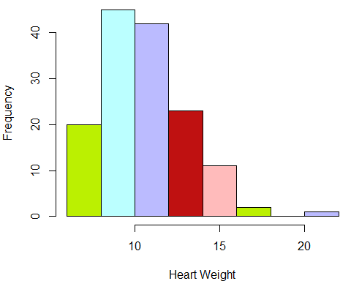
Fig. 1: A histogram of heart weight of cats in grams
The distribution of heart weight of 144 cats (in grams) is right skewed (positively skewed) since the right side of the peak is longer than the left side and unimodal thus there is only a single highest value. This implies that the mean is greater than the median, which is greater than the mode. There is an outlier.

### STEM AND LEAF PLOT
## The decimal point is at the |
## 6 | 355
## 7 | 0122333466799999
## 8 | 01233455567777888
## 9 | 000011113344455666666778899
## 10 | 001111111122244566667899
## 11 | 00012234555667889
## 12 | 0001223445577789
## 13 | 0003335568
## 14 | 1344889
## 15 | 0467
## 16 | 8
## 17 | 2
## 18 |
## 19 |
## 20 | 5
Fig. 2: A stem and leaf plot of heart weight of cats in grams
The distribution of heart weight of 144 cats (in grams) is right skewed (positively skewed) since the lower part of the leaf is longer than the upper part and unimodal thus there is only a single highest value which is 20.5. This implies that the mean (which is about 10.6) is greater than the median (which is about 10.1), which is greater than the mode (which is about 8). There is an outlier.

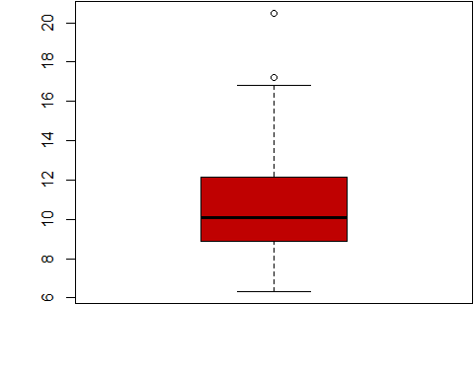
Fig. 3: A box and whisker plot of heart weight of cats in grams
The distribution of heart weight of 144 cats (in grams) is right skewed (positively skewed) since the upper part of the whisker is longer than the lower part and Most of the data are on the left side of the plot. Out of 144 cats, about 25% of the cats’ hearts weighs between 6g and 9g, about 25% of the cats’ hearts weighs between 9g and 10g, about 25% weighs between 10g and 12g and about 25% weighs between 12g and 17g. one cat’s heart weighs about 20g (which is an outlier). The heart weight of the cats is 6g and the highest is 17g.

